**Introduction**

Green energy is the energy of the future. Unfortunately, most means of green energy production do not have a constant output, since the sun doesn’t shine at night and the wind is quite fluctuating as well. With more households getting solar panels and turbines it makes sense to store the energy in batteries at peak hours so it can still be used when production is low. This way the batteries can be used as a constant energy source on the already existing energy-delivering network (the net). The new infrastructure, a *Smart Grid* of consumption-production, is by no means trivially configured. So the challenge is: ‘Which houses should be connected to which batteries, and where should they be placed?’

**Example**

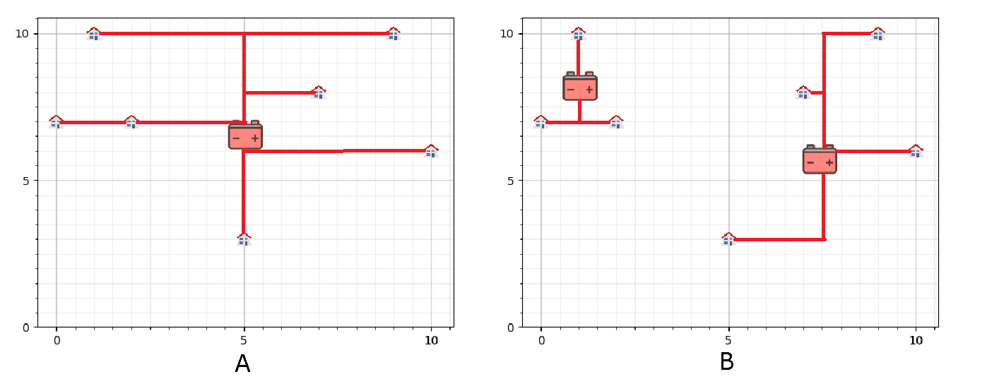

This neighborhood has seven houses with solar panels. As you can see in setup A the total wire length used for the setup is nearly twice the amount in B because the tactical placement of an extra battery. Do these savings in total wire length amount to the cost of placing an extra battery however?

**Boards**

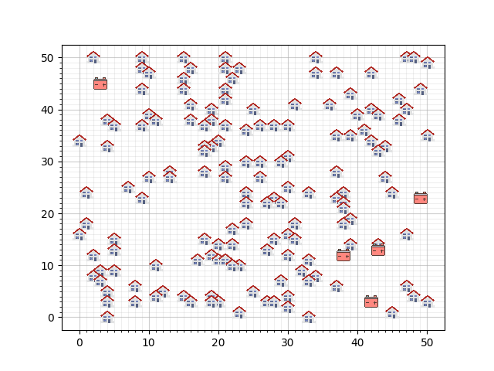

**I)**

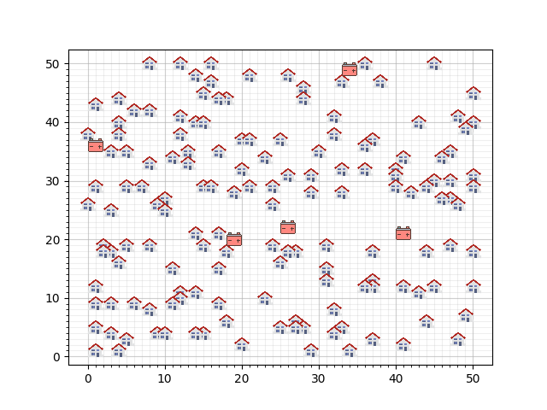.

**III)**

**II)**

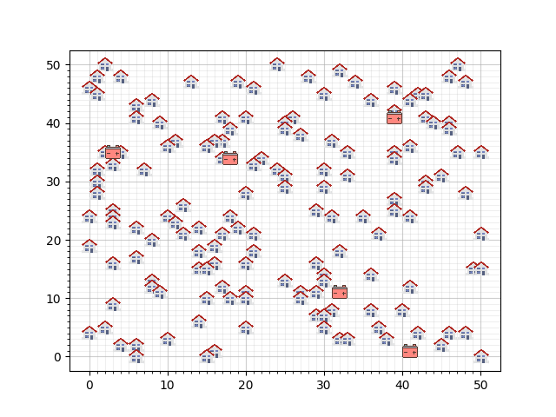

**Assignment**

To keep things a bit manageable a few simplifications have been made. The variable time has been taken out of the equation for example and all houses are on a grid. The assignment is to find a setup that gives an optimal cost for wires and batteries. Wire length is measured in *Manhattan distance* and it’s price is 9 per segment*.* There is one *hard constraint* however, each battery has a maximum capacity and is not allowed to be over-capacitated output to avoid explosion danger.

**A)** The city council of the neighborhoods that opted for a smart grid have proposed a few favorable spots where the batteries must be placed. Connect all houses (same as the maps above) to one of the batteries.

Apart from the feasibility, costs are also an issue. These fixed batteries all cost 5000. The cost function is given by:

Cost = sum(battery * battery price) + (wire length * 9)

**B)** Calculate the cost of your setup and try to optimize it further (if possible)

**TODO FROM HERE**

**C)** A few representatives from the neighborhoods convinced the city council that the cost might be drastically cut if the position of the batteries could be varied. Is this true? Why? Try to improve the results (lower the cost) found in exercise A by loosening the positions of the batteries (e.g. move the batteries). A battery can be placed anywhere except on a grid point.

**D)** Due to the research done earlier in A and B, SomeBatteryCompany Inc. saw some feasible business opportunities. They made three new types of batteries which are listed below. The residents of the neighborhoods ask you to come up with a plan to store all their energy as cost-efficiently as possible. You can place batteries anywhere, and use as many of each battery type as you think you need.

**Battery types:**

#1 Cap: 450 Price: 900

#2 Cap: 900 Price: 1350

#3 Cap: 1800 Price: 1800

**E)** Everybody is getting more and more excited about the smart grid and the city council gave permission for implementation. However, some residents raised concerns that they did not like the fact that many of the cables ran underneath their houses and gardens. The residents agreed that if a cable would run under some residents house, those residents would earn a compensation of 10.000 euro.

**Advanced**

When is it harder to satisfy the constraints and what makes it easier or harder to determine which battery configuration to choose?